# CS 255 System Design Document Barnard

This template lays out all the different sections that you need to complete for Project Two. Each section has guidance to prompt your thinking. You will need to continually reference the interview transcript as you work to make sure that you are addressing your client’s needs. There is no required length for the final document. Instead the goal is to complete each section based on what your client’s needs are. Remove this note when you are finished, and replace all bracketed text with the relevant information.

## UML Diagrams

### UML Use Case Diagram

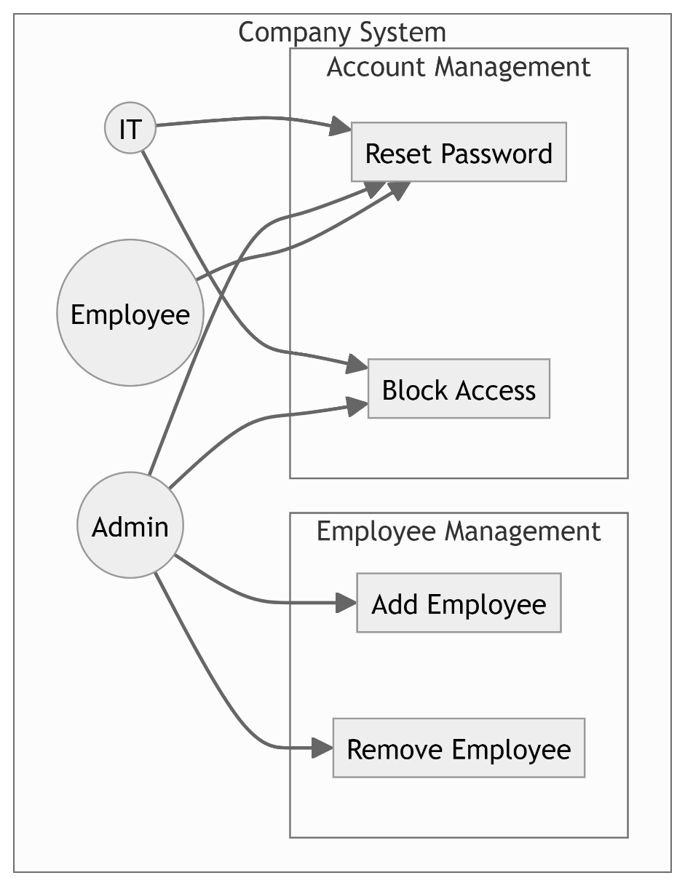

### UML Activity Diagrams

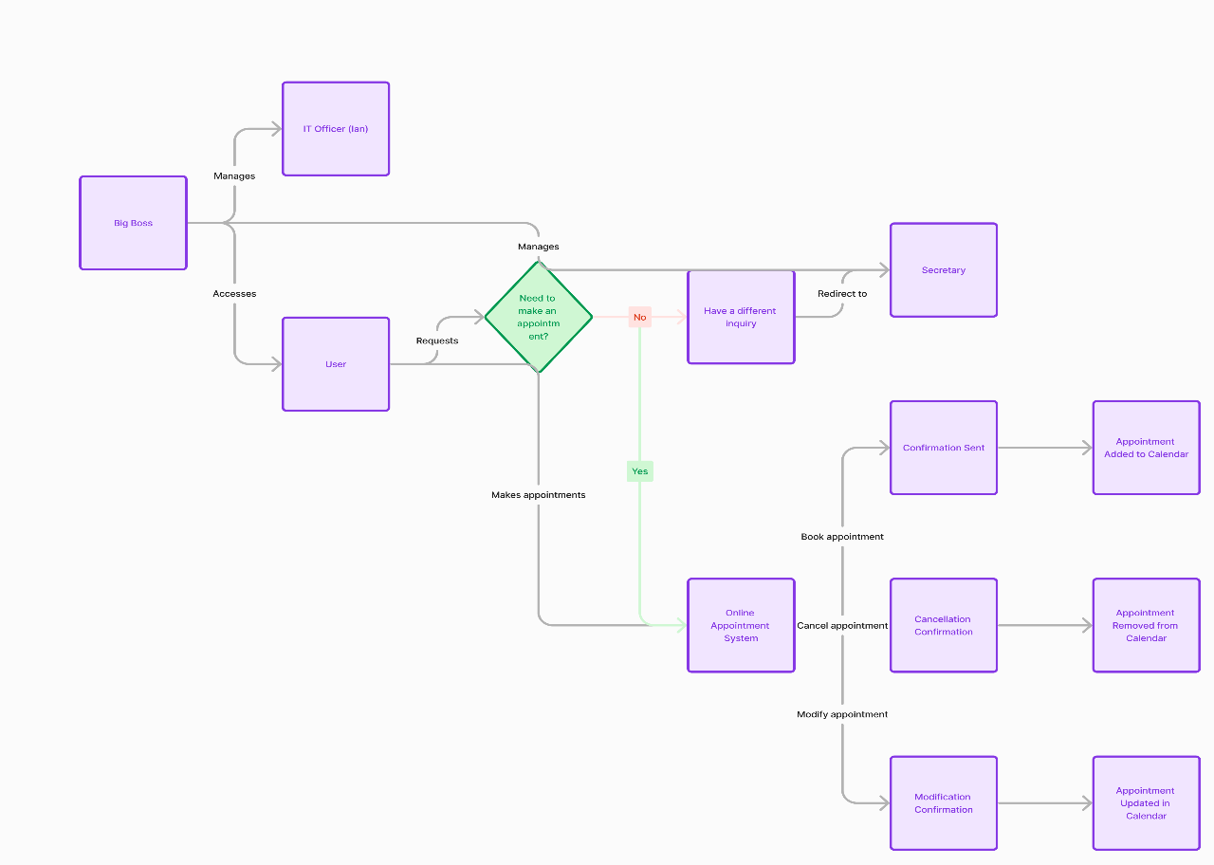

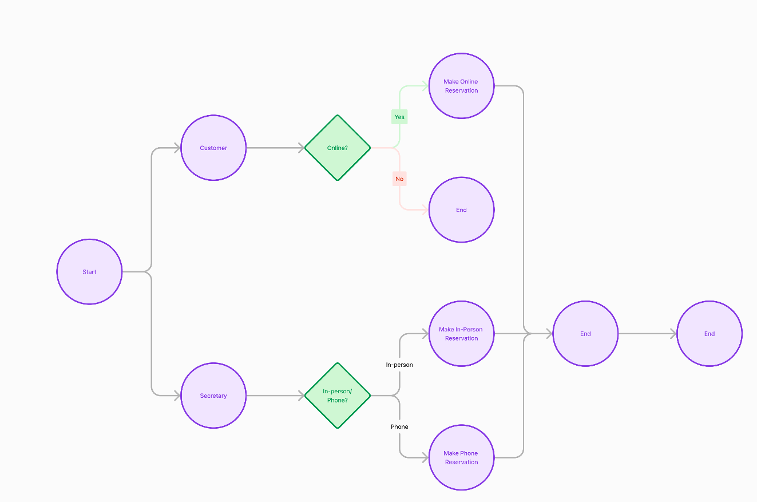

### UML Sequence Diagram

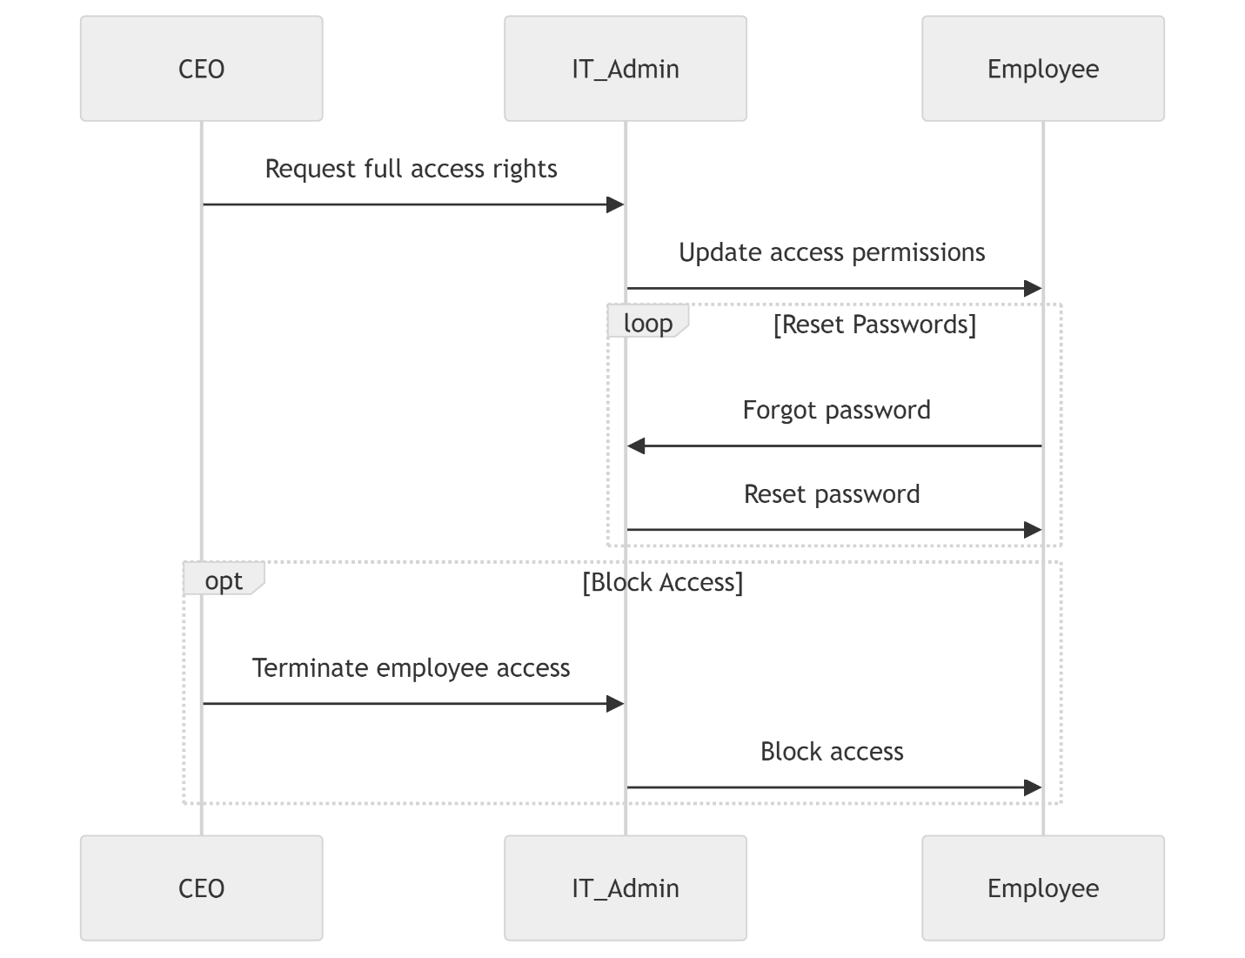

### UML Class Diagram

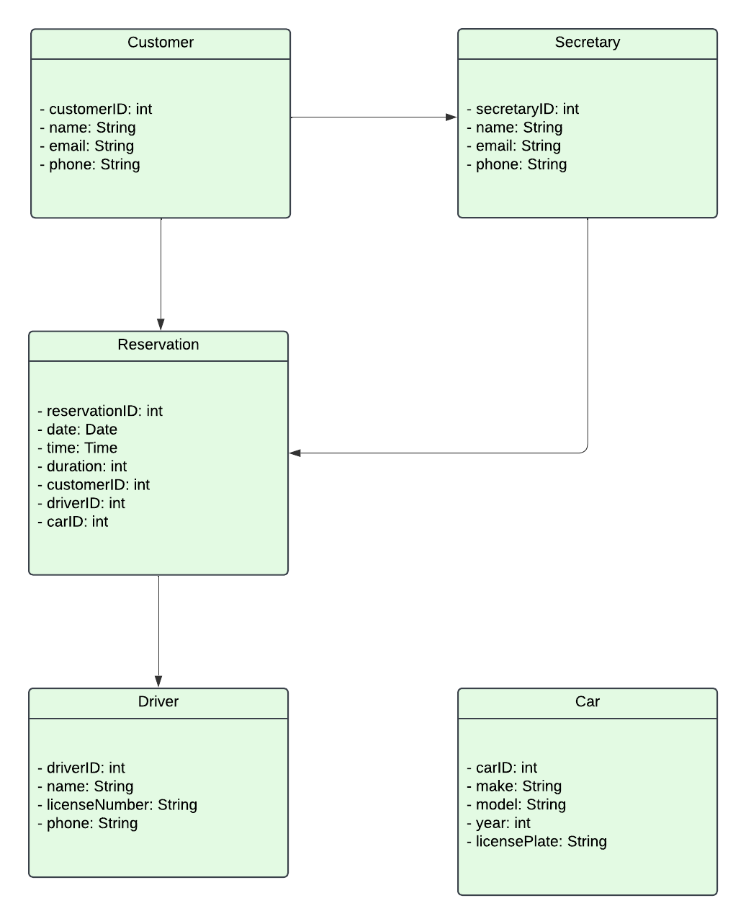

## Technical Requirements

**1. Hardware Requirements**

* A web server is necessary in order to host the APIs and web application. It must be adaptable to deal with fluctuating traffic.
* To store and manage the data about clients, reservations, drivers, and vehicles, a database server is needed. It should be able to effectively manage read and write operations in parallel.

**2. Software Requirements**

* A dependable server operating system such as Windows Server or Linux (such as Ubuntu Server).
* Any modern and current operating system like Windows, macOS, iOS, Android, or Linux.

**3. Tools and Libraries**

Sublime Text or Visual Studio can be used to write and debug application code.

Pymongo is a library for Python to interact with MongoDB.